INNOVATION, EMPLOYABILITY PROFESSIONAL READINESS FOR AND ENTREPRENEURSHIP

ASSIGNMENT-1

# SMART HOME

SUBMITTED BY

SUMI R

REG NO:961819106055

BATCH: B12-6A2E

DOOR BUZZER USING PIR SENSOR AND

PUSH BUTTON

CODE

// Door Alarm Using Arduino UNO and Ultrasonic Sensor

// Code to be used in the Text sub-window of tinkercad.com circuit page

#include<Servo.h>

Servo s;

void setup()

{

Serial.begin(9600);

pinMode(4,INPUT);

pinMode(12,OUTPUT);

pinMode(2,INPUT);

s.attach(8);

}

void loop()

{

int p=digitalRead(4);

Serial.println(p);

if(p!=0)

{

for(int i=0;i<1000;i=i+10)

{

tone(12,i);

delay(100);

noTone(12);

delay(100);

int a=digitalRead(2);

if(a==0)

{

for(i=0;i<=180;i++)

{

s.write(i);

delay(100);

}

for(int j=0;j<=30000;j++)

{

int b=digitalRead(2);

if(b==0)

{

for(int k=180;k>=0;k--)

{

s.write(k);

delay(100);

}

break;

}

}

break;

}

}

}

}

TINKERCAD LINK:

<https://www.tinkercad.com/things/8VLuDpB3b00-tremendous-trug/editel?sharecode=883U6PKa_WvUW_yO8lVTqjRTXj2-dMZMhBfb7okYhh0>

Figure:

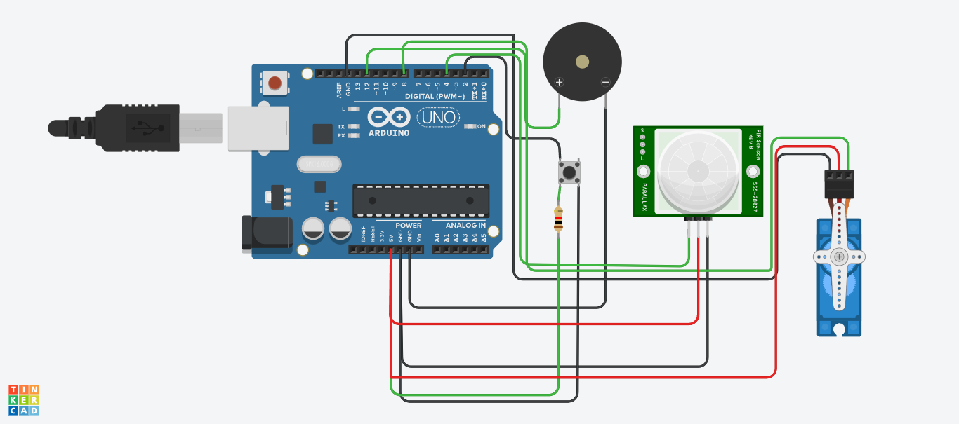

When someone comes in front of door ,the PIR sensor detect the motion of a person and the buzzer starts to ring. When the button is turned ON the buzzer stops and the stero motor starts to rotate and the door gets opened automatically. After a person comes into the home, the button would be pressed and the door get closed automatically again with the help of stero motor.